Lab 3A – Intro to Unit Testing with JUnit

Lab Intro
Key Term – Automated Testing
Automated testing involves using software tools to execute predefined test cases on a software application, comparing the actual results with expected outcomes. This approach enables efficient and consistent verification of software functionality without manual intervention.
This will be our first lab utilising a popular automated testing framework, JUnit, to conduct testing on a system.

Learning Outcomes
By the end of this session, you will be able to:
- Be proficient in understanding the fundamental concepts and benefits of unit testing, equipping you to make informed decisions on when and how to apply it.
- Apply your understanding of unit testing to write and annotate test cases using JUnit, focusing on the use of various assertions to validate code behaviour.

Resources
- Week 3 Lecture Slides

Lab Setup
Let’s begin by setting up our IntelliJ environment as shown in the lecture (creation of a test folder to house our unit tests).
- Begin by launching IntelliJ and create a new project with a sensible name (e.g. “STQA Lab 3A”). Ensure you select your location as W: (workspace) drive (Figure 1).
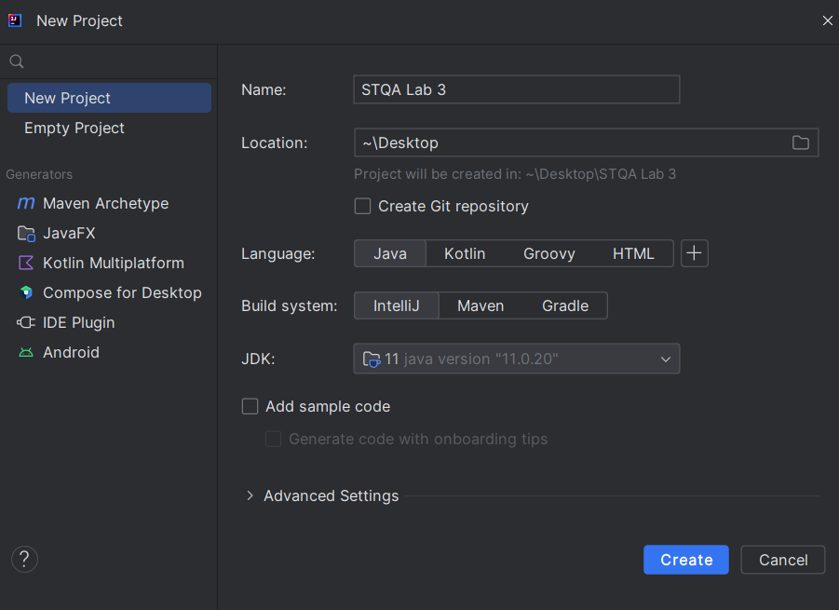
Figure 1 IntelliJ Project Creation Screen
- Right-click on your project’s root folder (STQA Lab 3) and select New > Directory (Figure 2)
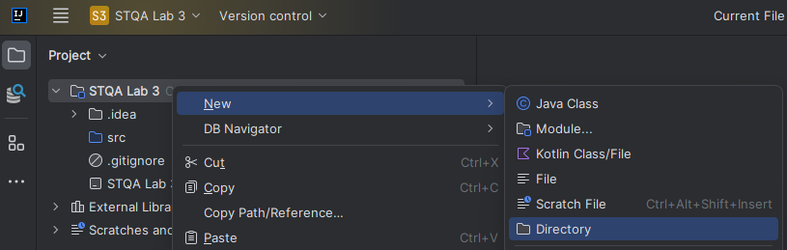
Figure 2 Creation of New Project Directory
- Name this directory “test” and hit enter/return (Figure 3)
Good Practice – test Directory
Place your test code in a separate test directory, mirroring the package structure of your main codebase. This makes it easier to locate corresponding test classes.
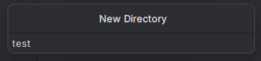
Figure 3 New Directory Name
- Right-click the newly created test folder and select “Mark Directory as” > “Test Sources Root” (Figure 4)
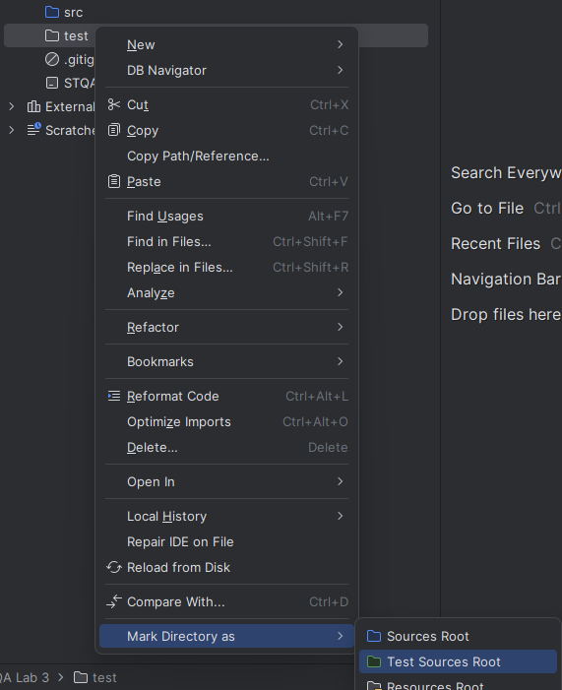
Figure 4 Mark test Directory as Test Sources Root
- Your project structure should look like that of Figure 5 (test folder should appear green indicating IntelliJ associates it as the folder that will house your unit test classes). If your project does not look like this, feel free to seek assistance in the lab.
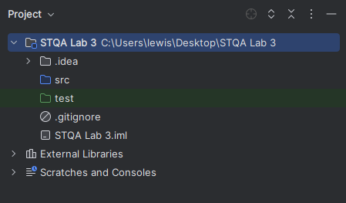
Figure 5 STQA Lab 3 - Project Structure
The first exercise will walk you through re-creating the Calculator example we did in the lecture, and will then add more complexity as we go.

Exercise 1 – Recreate Calculator Test Environment
Let’s see if our testing environment works by re-implementing some of the example unit tests conducted in the lecture.
- In the src folder, create a new class named Calculator (Figure 6)

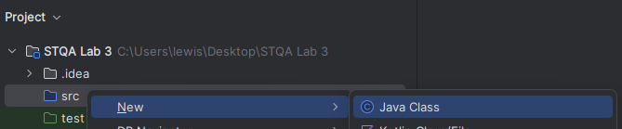
Figure 6 IntelliJ - Creating a New Class
- Add a method to this class that performs a common mathematical operation (e.g. division – supplied below if you are new to Java)

int division(int dividend, int divisor) {
return dividend / divisor;
}

- We are now able to perform some unit testing on this method. Right-click on the Calculator class name and select Generate… and then select Test… (Figure 7 & Figure 8)

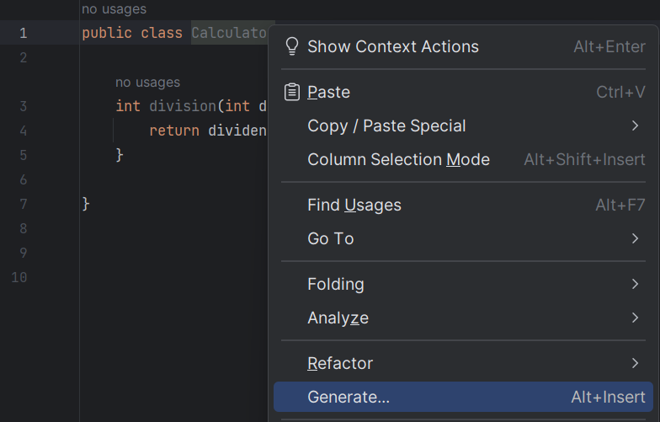
Figure 7 Generating a Test Class (Part 1)
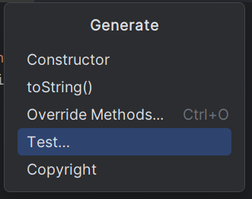
Figure 8 Generating a Test Class (Part 2)
- You should see the window presented in Figure 9. Click on the Fix button to begin the process of downloading the JUnit5 libraries
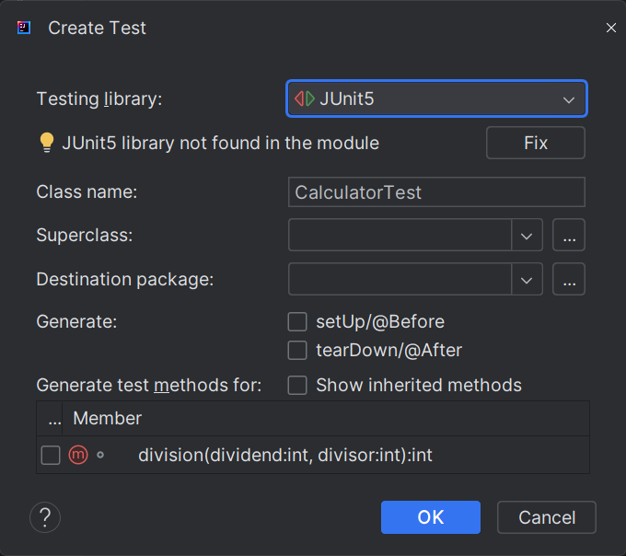
Figure 9 JUnit Test Creation Window
- You can then click on OK to download the JUnit5 libraries.
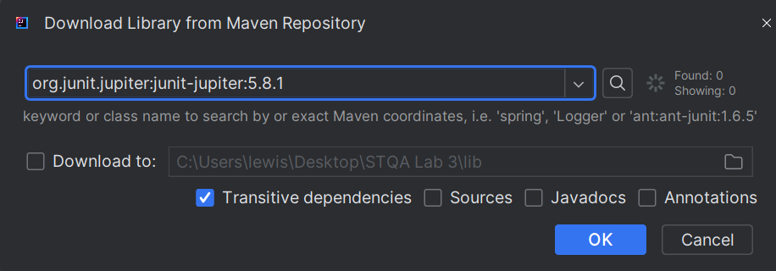
Figure 10 Downloading JUnit5
- The JUnit Test Creation Window should now look like it does in Figure 11 (the Fix button should have gone away since you have downloaded the JUnit5 libraries). Something I did not do in the lecture, was to tick which members to generate test methods for. You can do this now: tick the box for your method as shown in Figure 11.
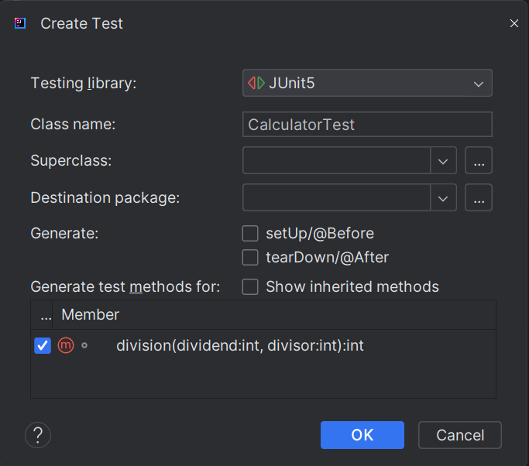
Figure 11 JUnit Test Creation Window (After Downloading JUnit5)
- If you have followed the steps so far, your environment should look something like that of Figure 12.
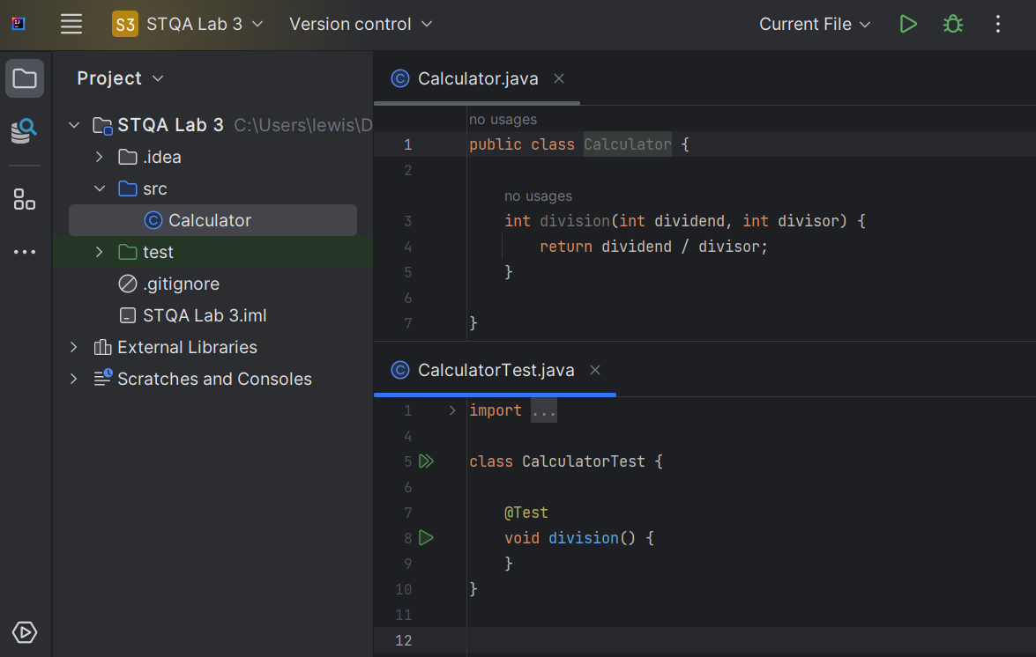
Figure 12 Project Structure so Far
Key Term – @Test Annotation
The @Test annotation marks a method as a test case to be executed by the testing framework (JUnit5 in our case). It signals that the annotated method contains assertions to validate a specific piece of functionality.
- You will notice the test method that IntelliJ has generated is annotated with the @Test annotation that was introduced in the lecture. IntelliJ has also given the test method the same name as the method in the class (i.e. both the business logic method and the method used to test it are both called “division”).
- You can actually run the division test method now – either click on the double-green arrow to the left of CalculatorTest or click on the green arrow to the left of void division. The test should pass (Figure 13).
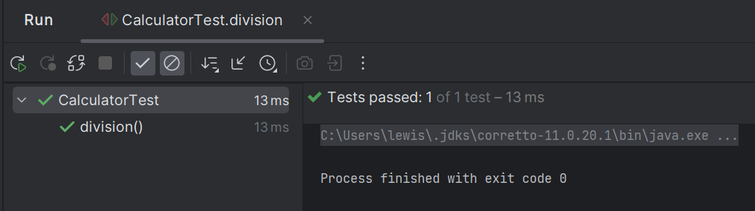
Figure 13 JUnit Test Passing
- You might be a little confused as to why our test passed in this case – how can a test pass when we haven’t asserted anything? Answer: An empty unit test automatically passes because it doesn't contain any assertions that could fail. In essence, it meets all its "conditions" by default, as there are none specified. Since no failure conditions are present, the testing framework marks it as passed.

- We can now modify our test method so that it contains the three core components of a unit test – 1) Arrange 2) Act 3) Assert
Key Term – AAA
AAA stands for Arrange, Act, Assert.
Arrange: Set up the conditions for the test (e.g. creation of an object).
Act: Execute the functionality to be tested (e.g. call an object’s method).
Assert: Verify the outcome is as expected by performing an assertion.
  - Your test method should check if a positive integer can be divided by another and returns the correct result. In your test method, add the necessary statements that map to the three A’s. i.e. 1) create a calculator object, 2) perform a calculation, 3) assert the result is what you expected. Use the lecture slides if you need a reminder of this process.
- Run the test method again and ensure it passes.

Exercise 2 – Adding a Second Unit Test – Check Division by Zero
This exercise will involve adding another test to the CalculatorTest class. Recall from the lecture that we can have multiple unit tests that test the functionality of a single method.

Task: Add another test method to the CalculatorTest class that tests if dividing by zero generates the appropriate exception (Note: we did this in the lecture). Run the test to ensure it passes.

Exercise 3 – Adding a Unit Test from a Name
Recall from the lecture that giving our unit tests clear and unambiguous names is important so that we can clearly determine what is being tested, under what scenario, and what the expected output should be. One common convention is:
test<System Under Test>_<Condition or State Change>_<Expected Result>
Task: Based on the name below, add the AAA sections that you would expect to see based on the name. Run the test to ensure it passes.

@Test
void testIntegerDivision_WhenThirtyIsDividedByThree_ShouldReturnTen() {
}

Exercise 4 – @DisplayName Annotation
As we saw in the lecture, giving our testing methods clear names often leads to such names being incredibly lengthy, which makes them cumbersome to analyse when viewing our testing results.
Key Term – @DisplayName Annotation
The @DisplayName annotation in JUnit is used to provide a custom, descriptive name for a test method or test class. This name is displayed in test reports, making it easier to identify what each test is designed to check.

Task: For each of the test methods you have implemented, use the @DisplayName annotation to provide a more concise name for the test. Re-run your tests to ensure you have implemented the @DisplayName annotations correctly.

Exercise 5 – Adding a @BeforeEach method
Key Term – @BeforeEach Annotation
The @BeforeEach annotation marks a method to run before each test in a test class. It's commonly used for setup tasks like initialising objects or setting initial conditions.

Another thing we saw in the lecture is how to reduce the duplication we have in our test methods by placing any code that needs to be run before a test runs into a dedicated @BeforeEach method.

- Add a method named beforeEach to your CalculatorTest class. This method should return nothing (i.e. void).
- Add the @BeforeEach annotation to the method. Note: You do not need to add a @Test annotation to this method, as the method itself is not a test – it is a method to help facilitate existing tests.
- Declare an instance of a calculator object as part of the class.
- Add a single statement to your beforeEach method that creates a Calculator object.
- Now that you have this method to create a calculator object, you can remove the statements from the test methods you made previously that created calculator objects.
- Re-run all of your tests to ensure they all still pass.

Exercise 6 – BMI Calculator
In this exercise, you will work with a simple BMI (Body Mass Index) Calculator. Your task is to create unit tests to verify the functionality of the provided BMI Calculator code.

One way of calculating a person’s BMI is as follows:

BMI = Weight (kgs) / Height in meters²

A person’s BMI puts them in a pre-defined category:
- Below 18.5 – underweight
- Between 18.5 and 24.9 – healthy
- Between 25 and 29.9 – overweight
- 30 or over – obese

- Download BMICalculator.java from Moodle and drag this file into your src folder to import it into your project.
- Generate a Test Class for the BMICalculator class using the approach we used earlier (right-click the BMICalculator class name in the code editor and go to Generate… and then select Test… Leave the defaults as they are (do not generate any test methods using the pop—up window, you’ll generate your own test methods after you’ve designed some test cases).
- Before you start writing the tests in IntelliJ, it would make sense to write down what test cases you intend to implement and execute and what you would expect the result to be based on your interpretation of the BMI calculation and categories provided. Using Table 1 to help guide your testing, complete the table (except for the final column – “Actual Result”), which you should complete after conducting your tests. The first row contains an example. There is guidance for filling in this table below the table itself, and you are free to add new rows/test cases as you see fit.
Table 1 Exercise 6 Sample Test Cases
Test Case # | Method to Test | Test Description | Inputs | Expected Output  (Note: rounded to 2 decimal places) | Test Case Implemented and Executed | Actual Result
Example  1 | calculateBMI | Valid weight and height | Weight (kg) – 70  Height (meters) – 1.75 | 22.86 | ✔ | 22.86
2 | calculateBMI | Valid weight and height | Weight (kg) –  Height (meters) –
3¹ | calculateBMI | Weight is zero | Weight (kg) –  Height (meters) – | IllegalArgumentException
4 | calculateBMI | Height is zero | Weight (kg) –  Height (meters) – | IllegalArgumentException
5 | calculateBMI | Negative Weight | Weight (kg) –  Height (meters) – | IllegalArgumentException
6 | calculateBMI | Negative height | Weight (kg) –  Height (meters) – | IllegalArgumentException
7 | classifyBMI | BMI < 18.5 | BMI – | “Underweight”
8 | classifyBMI | 18.5 <= BMI < 24.9 | BMI – | “Normal weight”
9 | classifyBMI | 24.9 <= BMI < 30 | BMI – | “Overweight”
10 | classifyBMI | BMI >= 30 | BMI – | “Obese”

Guidance for filling in Table 1:
When choosing the value of the different inputs (e.g. weight and height), there are different techniques we can use to pick what these values should be:
  - Human-generated Random Values: We can choose values at random based on the test description/criteria using our own intuition and judgement. E.g. for the 1st row/test case, a valid weight and a valid height are being tested, so any ‘sensible’ value makes sense here, so we can come up with these values ourselves.
  - Computer-generated Random Values: A program can generate random input values within defined ranges or according to some distribution. This provides a wide variety of test cases and can cover a lot of ground quickly.
  - Boundary Values: Specifically test the edges of input ranges where behaviour changes or errors are likely. For example, if an input can range from 1 to 100, test at least 1, 100, and some values around them like 0 and 101. Read this article for more information regarding boundary values and equivalence class partitions.
I would strongly recommend you test the boundaries of the different BMI groupings. You should add new rows/test cases to Table 1 based on the testing you will perform at the different boundaries.
- When you are happy with the test cases you have defined in Table 1, implement and run them. Highlight/note any defects you discover based on running your test cases.
Key Term – Boundary Value Analysis
Boundary value analysis tests the edges of input ranges where behavior changes or errors are most likely to occur. It focuses on the minimum, maximum, and just outside these limits to catch potential issues.

Lab Summary
In this lab, we have looked at the fundamentals of unit testing, focusing on creating and executing tests using the JUnit framework. Through hands-on exercises, you've learned how to write basic test cases, employ assertions, and use advanced features like annotations for test setup and teardown. We've also delved into critical test design techniques such as Boundary Value Analysis and Equivalence Class Partitioning to select effective test inputs. By the end of this session, you should have a robust understanding of how to build a comprehensive unit test suite to improve software quality and reliability.

The lecture slides for this week cover how you can assert an exception. In that example, the String message we were expecting was “/ by zero”, since that example was testing a vision by zero error. In this case, our IllegalArgumentException in the BMICalculator class throws a new IllegalArgumentException where the String is “Weight and height must be greater than zero”.

